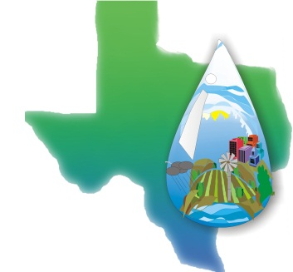
Brazos Valley Groundwater

Conservation District

P.O. Box 528 · Hearne, TX 77859 · (979)279-9350
www.brazosvalleygcd.org
Notice is hereby given that the groundwater conservation districts located wholly or partially within Groundwater Management Area (GMA) 12, as designated by the Texas Water Development Board, consisting of the Post Oak Savannah Groundwater Conservation District (GCD), Fayette County GCD, Lost Pines GCD, Mid-East Texas GCD, and Brazos Valley GCD, will hold a Joint Planning meeting at 10:00 a.m. on Thursday, March 18, 2021.
Notice is hereby given that, in accordance with Governor Abbott’s March 16, 2020, action to temporarily suspend certain provisions of the Texas Open Meetings Act, a Joint Planning Meeting will be held via telephone and video conference call beginning at 10:00 a.m. on March 18, 2021. Any member of the public who wishes to participate remotely may do so through the remote access options provided below.
Please join the meeting from your computer, tablet or smartphone at:
https://global.gotomeeting.com/join/400538117
You can also dial in using your phone:
United States: +1 (786) 535-3211
Access Code: 400-538-117

The subjects to be discussed or considered, or upon which any formal action may be taken, are as listed below. Items may or may not be taken in the same order as shown on this meeting notice.
1. Invocation
2. Pledge of Allegiance
3. Call meeting to order and establish quorum
4. Welcome and introductions
5. Public Comment on Agenda Items
6. Minutes of February 12, 2020 Groundwater Management Area 12 (GMA12) Meeting
7. Update from Groundwater Conservation Districts (GCDs) of GMA 12 on joint planning, water level monitoring,
and compliance with Chapter 36.108, State Water Code
8. Discussion of comments received from stakeholders
9. Evaluation, discussion and consideration of past and future pumping scenarios using the Sparta/Queen
City/Carrizo-Wilcox Groundwater Availability Model (GAM) and results, including predicted water levels and
water budgets
10. Consider Proposed DFCs for aquifers in GMA 12
(a) Sparta
(b) Queen City
(c) Carrizo
(d) Calvert Bluff
(e) Simsboro
(f) Hooper
(g) Yegua-Jackson
(h) Brazos River Alluvium
11. Discussion and consideration of expressions of Desired Future Conditions and compatibility, including
acceptable variances in values between GCDs in GMA 12
12. Discuss requirements of Chapter 36.108(d) in adopting Desired Future Conditions:
(a) the feasibility of achieving the desired future conditions
(b) any other information relevant to the specific DFCs
13. Declaration of Non-Relevant aquifers by GCDs in GMA 12 for current round of joint planning
14. Schedule and process moving forward for adoption of DFCs
15. Public Comment on non-agenda items
16. Update from Texas Water Development Board
17. Agenda items and Date for next meeting
18. Adjourn
Signed this 3rd day of March, 2021.
Alan M. Day, General Manager, BVGCD
112 W. 3rd Street, Hearne, Texas 77859
Phone: 979-279-9350

**Questions, requests for additional information, or comments concerning the subjects listed above may be submitted to the person posting this notice.

